1992 | طاقم شؤون المرأة  Women's Affairs Technical Committee, Palestine

Annual Report
Highlights
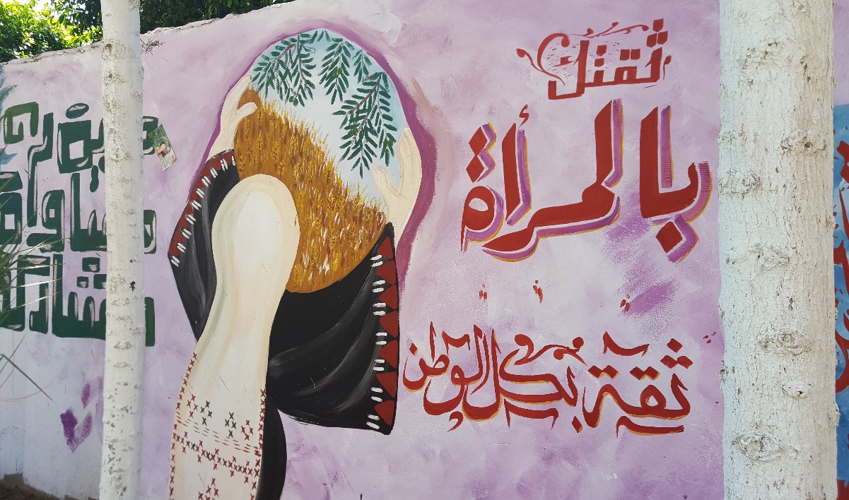
Major Accomplishment

The Situation of Women’s Rights in 2017

The year 2017 was a challenge to the human rights and women's rights in the Palestine. The division had a negative effect on human rights, the confiscation of freedoms and continued violations of life and the violation of the personal safety of citizens, especially women. The killings have increased due to the misuse of weapons outside the law and the killings of women on different backgrounds, including a murder, which was recorded as “crime of honor”. The most serious of which was an incident of misuse of weapons that killed 41 Palestinians, including 10 women, 3 children. There was 9 cases of killings of women in Gaza, and the murder of one woman in the West Bank, and this is one of the most serious violations of the right to life and assault on the personal safety of female citizens.

- The use of the death penalty and its implementation in Gaza without the President's approval. This is a serious violation of the Palestinian Basic Law of 2003. Two women were sentenced to death in Gaza.

- Disrupting the local elections in Gaza where elections were held in the West Bank only. This was due to the continued control of Gaza by Hamas and the continued division. This has deprived the citizens, specifically women, from actively participating in the selection of their representatives. The local councils in do not include women, while the law guarantees the minimum of 2 seats for women in each council.

- The deterioration of the situation following the political division on the economic and social rights in the Gaza Strip. The statistics indicated increased rates of poverty, unemployment and gender based violence.

- The significant increase in the prevalence of serious diseases such as cancer among women, which is the cause of the highest mortality rate for women.

- The rise in the divorce rates in the Sharia courts compared to that in 2013, which is due to the pertaining economic conditions in Gaza Strip.

- A clear decline in women's political participation and their absence from efforts for reconstruction, reconciliation and national dialogue with the mere presence one woman.

The work of the Women’s Affairs Technical Committee was in accordance to its plan for 2017, which was prepared on the basis of its strategy. After reviewing the implementation plan set for 2017, it became clear that about 95% of the plan was achieved.

During 2017, WATC worked at raising the voice of Palestinian women at the local, regional and international levels on more than one issue through our partnering with the Women’s Learning Partnership (WLP); such as in the regional project to review the personal status law, which the partnership aspires that it becomes a high-profile campaign.

In addition, empowering and building the capacities of Arab leaders through specialized courses held with the contribution of all partners in the organization. WATC is one of the main contributors to these interventions. Moreover WATC had a role in identifying international advocacy priorities with partners from the world, such as Spain, Basque and other countries.

In the Context:
On the other hand, in 2017, WATC entered into new partnerships that are important in terms of the common orientations between us and our partners. For example, the African Women's Development Fund (AWDF). Currently with the Palestinian NGO against Domestic Violence against Women (Al Muntada), the draft Family Protection Law against Violence is being reviewed, discussed and advocated for its adoption.

In addition, AWDF and WATC signed an agreement of cooperation and support in the area of ​​amending laws. Within this partnership, WATC conducted three workshops in three universities in the West Bank and Gaza Strip. The aim of these workshops was to conduct an interactive discussion with law, media and social studies students at universities on the Family Protection Law from Violence for review and discussion by students. Lawyers and university teachers were responsible for presenting the draft law and leading the discussion among students. The workshops reached a total of 180 participants, 93 women and 87 men. While indirect beneficiaries were about 560 beneficiaries, about 46% of whom were men. (WHO ARE THESE??? MAYBE WE NEED TO CLARIFY)

.

In addition, WATC was able to significantly overcome the financial crisis of 2016. Thanks to a series of decisions and actions taken by the Board of Directors, as well as the spirit of high belonging of the staff. The threat of the crisis continues, but in 2017 the dangerous phase was passed that the crew announced at the last General Assembly.

Achievements of 2017

Strategic objective 1:
Protecting women against all forms of violence and social marginalization, including the violence of the Israeli occupation:

1.1 Long-term outcome: Women are aware of their rights and have access to these rights and to relevant quality services in all governorates

During the year 2017, WATC supported the Palestinian NGO against Domestic Violence against Women (Al Muntada) through the media's participation in Al Muntada’s campaign on the importance of the adoption of the Family Protection Law against Violence. In this context, WATC staff continues with the rest of the member organizations in participating in the campaign as an essential group. Al Muntada held an open day in partnership, cooperation and coordination with the Ministry of Women on the occasion of International Women's Day (March 8), In the Tulkarem governorate, in which the Prime Minister promised to work towards the adoption of this law, noting that the law is still pending without approval. In addition, WATC staff is working with youth groups from universities to open a discussion among law students and students of the law, highlighting the importance of this law, its proposed provisions, and how to join the national campaign to pass the law. These discussions are an opportunity for students to express their views on the law. We also witnessed that these meetings open the door to discuss the impact of the absence of the Legislative Council, and the need to support all efforts to achieve political and community reconciliation.

In the coming period, focus will be on holding meetings between students and various decision makers, and opening a community dialogue on the importance and necessity of endorsing the Family Protection Law against Violence.

1.2 Long-term outcome: international institutions and agencies bear Israeli occupation accountable for violations against Palestinian women and their families.

Building the capacities of youth in Palestinian camps on UNSCR 1325 and related issues in international human rights

WATC, continued its joint work with the United Nations Refugees Work Agency (UNRWA) targeting youth and women in refugee camps in the West Bank at women’s centers, raising their awareness on existing international mechanisms, UN resolutions, and tools that seek treatment and responsibility. Furthermore, initiatives have been implemented in partnership with institutions working specifically with youth such as the Palestinian Youth Association for Leadership and Rights Activation (PYALARA). WATC, worked with a group of 240 young men and women and about 120 women through their positions inside the camp. Women cannot access to leadership positions in the Popular Committees in the camps. The membership of these Popular Committees is mainly formed from men in most sites. Although women are essential players in the political environment of the camps, the Committees have not yet worked to encourage and establish the foundations that encourage women’s participation within these committees.

On the other hand, WATC, is an active member of the National Women's Coalition for the توطين of Security Council Resolution 1325 and the National Committee for the same resolution. WATC, participates in all the work and activities of these bodies, in terms of meetings, taking various tasks, participates in the planning and development of indicators for plans. WATC, also gave a lecture to the professors of the University of Valencia, in Spain, and another for the students of the same university on this decision in the Palestinian context.

Strengthening the capacity of the Union of Women's Centers in the refugee camps on issues related to international human rights law and international humanitarian law, with special emphasis on resolution 1325.

WATC, held 3 extensive training workshops with the women's centers in the refugee camps. These workshops targeted a total of 62 women with 4 training days for each group. The workshops took place in the northern, central, and southern regions of the West Bank, including representatives of the camps of Am’ari, Qalandia, Jalazon, Aida, Dheisheh, A’rroub, Jenin, Nour Shams, Balata, and Askar. The meetings aimed to bring the views and discourse of the officials of these centers closer together, build their capacities in several field and open a collective discussion on issues of priority and interest to this group. The program is ongoing and will support the centers in their efforts and help them take a leading role in organizing women in the camps and enable them to make more decisions in their private lives as well as in the public sphere.

Improvement of the public discourse on media outlets to support women's rights/gender equality in a coordinated effort.

WATC, continued to publish the "Voice of Women" newspaper, in addition to training and empowering female and male media students especially as it relates to their knowledge of media and gender issues and training on gender sensitive discourse.

Media work has become an agreed strategy by the Media Coalition, giving stronger results and greater impact, as a result of organized action the Media Coalition. This Coalition was established by WATC, in 2016, with the participation and membership of Ma'an News Agency, Raya FM Radio, Nisa Radio FM, Palestine Television and Radio, Voice of the People Radio, Filistiniyat, Women Media and Development – Tam, and other media organizations; media work has become part of an agreed strategy by the Coalitions’ members, giving stronger results and greater impact, due to organized action by Coalition institutions.

Also, WATC, is a member of the Committee for the Development of Information and Curricula for women's and media courses at Birzeit University. All of these efforts are in line with a goal that we share with many other institutions: to create a courageous and professional media discourse that discusses community issues with a clear feminist vision.

Through the Media Coalition, and close cooperation with many media outlets, in addition to the initiatives of students and students of media in different universities, many short films are produced which in turn are used for courses, meetings and workshops depending on the subject. Here are some examples:
https://www.youtube.com/watch?v=3XfhlGJXPkE
https://youtu.be/R2ZjHzKgWR4

The Media Coalition, works in coordination with WATC, and all its members in order to produce a common productions that serves the agreed objectives. During 2017, most of the materials which were produced, focused on women's political participation. The Coalition, followed up on the production of several media outlets, and accompanied the female and male volunteers in all geographical areas and worked with them on several media productions. This comes within the Coalition’s objectives for joint media productions and disseminating them through websites and Facebook pages and other used outlets of its members. Thus, a qualitative accumulation of follow-up and evaluation of information on products produced by Coalition members is undertaken to highlight positive models of women's discourse and rights and build action plans that are based on the results of evaluations.

One of the most important lessons learned this year is the significance of having both men and women in the discussions on women's issues, the prominence of partnerships with the various media organizations to raise specific issues that are not sufficiently covered. One of the most important effects of the radio program is to provide space for our partners, women in cooperatives through the program to promote their work. Adopting the program as an important area in covering some social issues such as social security, invitation to attend and coverage of most conferences and activities for women to cover the program. Also upon the demand of our beneficiaries, the program held episodes on social security program, work of trade unions, women's working conditions, and pressing issues related to violence against women.

Strategic Objective 2: increase women's participation in decision-making positions

2.1. Long-term outcome: women in decision-making positions affecting decisions to serve women and national priorities

Within this goal and this long-term result, WATC, is working on more than one level, and during 2017, work focused on following up the commitment of the political parties to the Charter of Honour which was signed by 12 parties as an expression of their moral commitment to the issues of women's political participation, both within and outside the political parties. In this regard, the Code of Honour was activated and the capacity of 200 female and male activists from 20 locations in the West Bank and Gaza Strip were built. Through numerous activities, the group has engaged 1,200 young women, university and school students. Also, several initiatives were undertaken by the youth activists, which aimed at raising community awareness on the importance of women's participation in public and political life and on strengthening their capacities as a youth group to support women, and to be initiators and control things in their hands as young leaders. All initiatives had been considered, planned and implemented by the youth with the support and backing of WATC.

The initiatives were seen as an additional educational opportunity for the activists. They were not only trained in administrative aspects, but also in negotiations skills, fundraising and sustainability of initiatives. Activists have become more popular in their communities, more confident, and with greater self-esteem because they are linked to increased credibility.

More than 17,000 people benefited from the activities of the initiatives in 20 locations. Cross-cutting activities included: open meetings, discussions with political parties, public debates and open days in universities, and coordinated community activities with schools, popular organizations, murals, plays, etc.

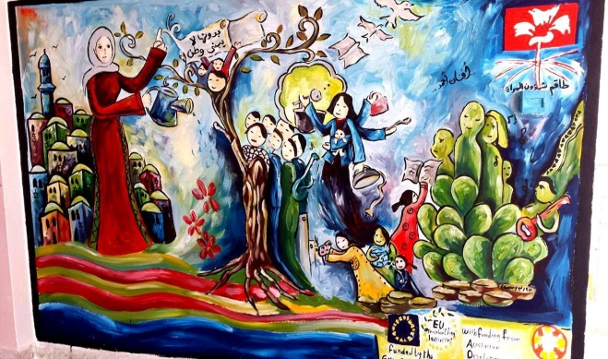
Painting of murals in West Bank locations:
Walls were painted focusing on women's political participation in 14 locations in the West Bank. The murals represent the different roles that women play in society.

Murals have been able to give visible messages that people still see daily, affecting people's thinking, and the nature of different perceptions and viewpoints of people about women's political participation. It places women in the public sphere where they are not favored by people in the local communities; these persistent messages that are being presented through murals is a very important tool to change people's attitudes and views about women's political participation.

Play Clothesline:
The theatre play "Clothesline" was performed in 14 locations in the West Bank, especially in schools. The play discusses the history of Palestinian women's political participation since the late 1980s and highlighted the social views on women's political participation, especially in elections and within political parties. The play shows the obstacles women face when working in the political sphere, especially those imposed by male colleagues.

Young men and women who attended the presentations received direct messages to increase the confidence of female students as young women, messages about the importance of women’s political participation, and provisions such as “you can to do what you want”, “there is no limit to your abilities”, “you are no less than anyone”, and “women's participation changes the status of women and communities to the best”. | 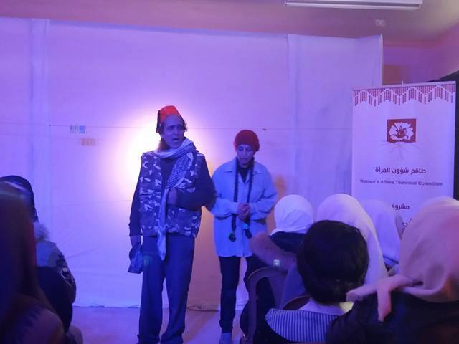
One of the project’s participants said: "This play gave us more than 10 workshops would have given us”. Our understanding of the concepts of political participation, women's participation and women's rights have increased. This presentation has added a lot to me”. It should be noted that each performance was followed by a discussion on political participation, the main issue of the play.

In addition to the aforementioned activities, the activists implemented different events in their locations. Activities included drawing competitions to represent women’s political participation, bloggers’ bus, marathon, open days, meetings with women leaders in political parties, accountability sessions for political parties, conferences about youth perceptions towards women participation, standup comedy and puppet shows for school students and their mothers. Below is a sample of selected initiatives that were implemented in West Bank and Gaza:

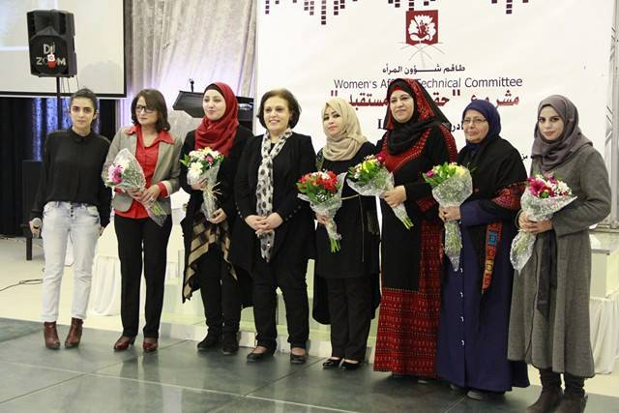
“Let’s Talk” initiative:
In Beit Lahya - Gaza, this initiative was inspired from the global event “TEDx”. Women from Beit Lahya were interviewed and selected to talk about their stories. Six women shared their inspiring stories with other people from different areas in Gaza. This event was shared on social media through hash tags, posts and reports.

This initiative was very important, because it gave those creative and successful women a chance to share their experiences with the community. It was not only important for the fact that the audience got exposed to role models that are successful in their communities, but also it was important for women who were able to share their stories for the first time with wider audiences. One of the journalists who came to cover the event said: “This is an amazing event; those women are great women with great stories.”

Decision makers visit to Habla

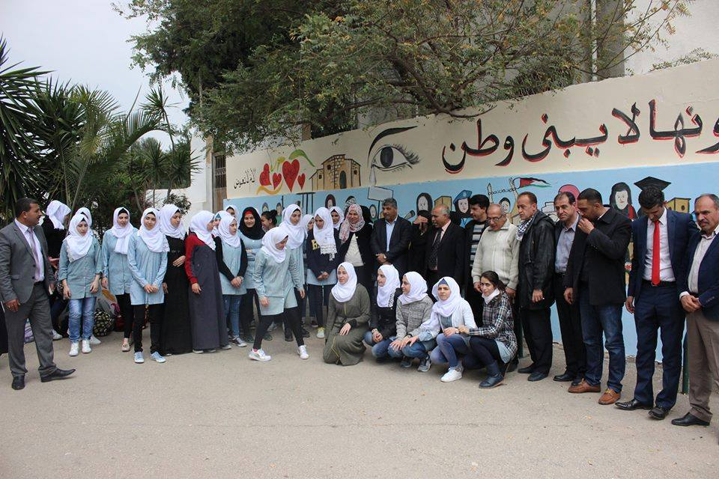
Habla, in Qalqilya, is one of the conflict affected locations in the West Bank. It suffers from land confiscations, the separation wall; especially due to its location which is surrounded by settlements. Women in Habla face many problems on a daily basis; they requested to have a meeting with decision makers to discuss their problems, share their needs with them and to hold them accountable for their responsibilities. The Minister of the Colonization and Wall Resistance Commission Walid Assaf, the General Director, and a delegation of the Ministry of Local Governance from Qalqilya branch, a delegation from the Ministry of Agriculture and a delegation from Qalqilya governorate and Habla local council participated in the visit.

After a round in the town, activists group, and school students questioned the visitors and demanded solutions to the problems they face in their daily lives. It was a chance for the young generation in the community to meet with decision makers and to stand for what they see important for them. Promises of change and follow up to their problems were made. The activists groups are following up with the different actors.

Building new political party cadres

In Salfeet, three training workshops were conducted for 20 participants (6 men and 14 women) in coordination and cooperation with the Popular Struggle Front political party, in order to increase the numbers of the political party skilled cadres in Salfeet, and to increase their knowledge in political participation and political party | 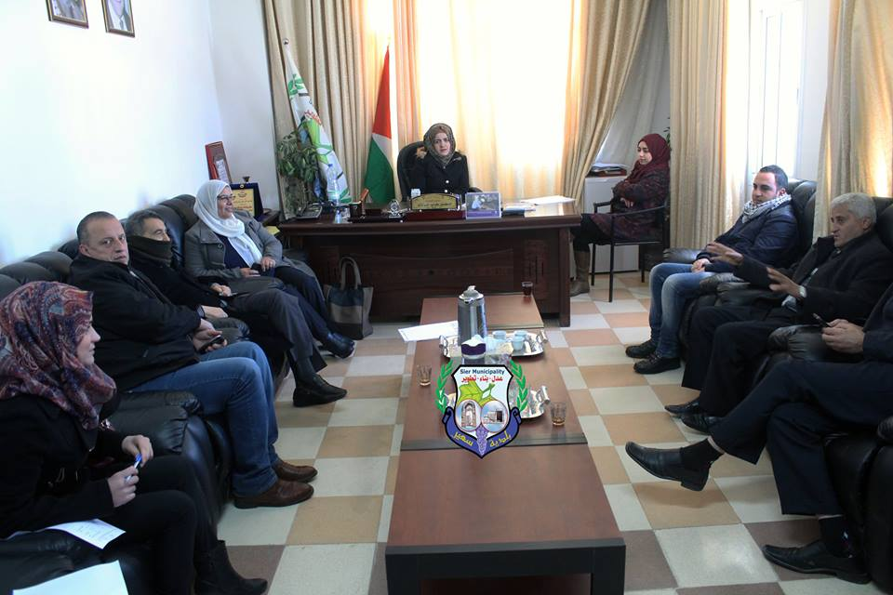
work. Mahmoud Naser, one of the trainees said: “I learnt that women should be in decision making positions as they were partners in the political participation from the beginnings. Men can’t stay selfish; they should be open the door to women’s political participation.”

Woman in the Municipality Initiative

In Sa’ir, the main activist in the group, Wisal Shalaldeh, who is interested in running for the position of the mayor in the coming elections, took the role of the Mayor of Sa’ir Municipality for three days. During those days, she held meetings, conducted visits to different locations, solved problems, took decisions and signed documents. She took the full role for three days; took decisions to support women’s needs in their community, and her decisions now are being implemented.

This initiative was new to the community of Sa’ir as this was the first time that a woman is in the Mayor position; it created big discussions about the idea of having a woman in such a leading and sensitive position. Some people were totally against it; some were very supportive of the idea. The most important thing is that this initiative opened the discussion about the possibility of having women in decision making positions; it broke the barrier of masculine leadership in Sa’ir, and opened the door to women to different roles in decision making positions, not only as mayors, but also in other positions.

Bloggers Bus

In Al-Maghazi - Gaza, the activists, planned for a bloggers bus trip to report on role models and women leaders. 50 journalists and activists participated in the trip that went around in Gaza city to meet with women leaders. The activists used the (#FiftyFifty) to express the importance of equality between men and women, and tweeted women’s stories on social media. Many people shared the posts and interacted with the published stories. | 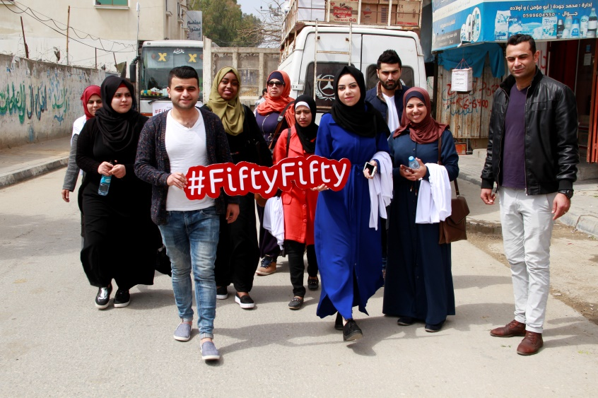

The project “Empowerment of Women in Political Participation” was implemented over 2016 and 2017, over a period of 12 months. Several activities were realized while engaging the Ministry of Local Government, local councils and municipalities, Ministry of Women’s Affairs, civil society organizations, and media professionals from different media outlets.
Conducted training for media organizations in the West Bank and Gaza Strip, which aimed to increase their knowledge on the importance of women’s political participation, and how to cover women’s issues in the media in a gender sensitive manner. This training targeted Ma’an Network, Palestine TV, Voice of Palestine, Falastyiniat, Radio Nas - Jenin, Wafa, Nisa FM, Ray FM.

The project has developed initiatives that are based on the actual needs of the communities and based on their suggestions. The local communities have discussed their needs through workshops in each location; their needs were voiced, and then the most pressing priority was jointly decided upon for the initiatives. Through our previous projects women members of local councils received training on how to hold workshops, communicate with their constituency, how to identify problems of their communities especially as it relates to women, and how to set themes for discussion during the workshops. This coaching helped them a lot to hold successful workshops with their constituencies. It is worth stressing the important aspect of the sustainability of these initiatives, where they do not end with the completion of the project. Local councils and municipalities have integrated these initiatives in their strategies and will continue to support them.
The change that has stemmed from this project is very impressive, be it on a personal level of the participants or in their professional capacities.
The project ended with a big conference with the presence of around 140 persons of which 30 were men and 110 women. The participants were local council members, CBOs of villages, General Union of Palestinian Workers, Trade Unions Federation of Palestine Professionals, FATAH, Union of Women’s Committees, UNRWA, Nisa FM, Palestinian Working Women Society for Development, Ministry of Agriculture, Al Bireh Health Centre, Al Bireh United Council of Schools, Amar Al Ard Society, Ministry of Local Councils, Cultural Heritage Society, Red Crescent Society, Union of Women’s Work, AMAN, Union of Women’s Struggle Committees. The conference presented the film around the initiatives, sessions presented by women local council members on their initiatives. The participants discussed the initiatives with the women and WATC team. This conference was a show case for other organizations on the great impact of cumulative work with the target groups, since WATC has been working for the empowerment of women’s political participation for several years.
Links for the conference coverage on WATC Facebook page:
https://www.facebook.com/WATCPAL/photos/ms.c.eJxNVMdxAEEI68hDEqH~;xjywB~;ZXw6KA7ljDyFIEBamKHx5AVMSFBPYBZVKSLkwfkEnzRGsnkD3BtU9Uq3ew7dI07gllXha3YRF5gBOLOKfF0RZLryx8gFn0jqAFsnSE4XQIt7CsfACIRmlyLQAapSQHWE~_E4~_w3oMgFSu3ZzxP2dvi3w~_BNq4I8YIQhVxiU2kvBP1qzEaaxwky9JBH8TZijAbfyi1B7h5t~_T9RtnuS6jdBeSrYsIPSE3xnUcu6iq1RiMs3AnoGqn~;CxBLVbGDYxxIQstrSp1pdz3CmzI~_TQbymKZ4fYJubp7SWJzn49~_0sLnloq~;UnHq9Q2KDR6R9iG7Nb2lWMTC~;M3scUFZU9cCxHRtYTmAYSmZbaV~;vKQzcNCMHeRuCf2nuB0TGFAG7LG0NpJlxoAsrROU~;7MLb9HDUv8y~_Odcr0EvX7ssbsdc0pZwOCdGOnZj1fLLZ0F5dtxtC8guc9Uc34GTHbHnkopxxWmn3BepvWAOiAVA5y5DEyTj8XHnGPNdR7TsWWxiJnQPPsvU7pM1X1CxhXXp5axfxgLfYndJxbx~_sH0C4bIBVE~-.bps.a.1374042065953613.1073742007.180934915264340/1374048225952997/?type=3&theater
It is worth noting that this project integrated media throughout the phases of the project, and the continuous coverage had a great impact for creating social dialogue, attitudes, and appreciation for women’s political participation.
This project opened horizons for WATC, for future projects with women local council members by continuing to support the established initiatives, and build on the gained experiences, since WATC team got to know the members, know their needs and that of their communities. Through the initiatives several activities could be implemented in the future to serve the women in their local communities. WATC worked with CBOs that were not contacted earlier and built networks with them, also this project boosted the confidence in WATC of the targeted women, local councils, and local communities. The trained women are reference points for WATC for future projects and activities. Also our relationship with media organizations was strengthened.
WATC participated in all the preparatory meetings for “Ana Wa Anta Watan Wahed” campaign, participated in the selection of the slogan along with UN Women, Working Women, and others. WATC participated in the preparation for the media conference and participated in it. WATC chose the name for the TV Program of Palestine TV “Ana wan Ant”. Also our Media Officer provided coaching for the presented of this program in the selection of the topics, guests, and questions. WATC participated in the majority of the campaign’s activities, especially in Ramallah. WATC boosted the campaign through covering its activities in the social media. Also, a TV episode on the role youth in the elections and the promotion of women in elections. This episode covered WB and GS and 14 youth (10 females and 4 males) were interviewed.
For the TV program on the campaign: https://www.youtube.com/watch?v=PTluGEhuJoc&feature=youtu.be
Facebook page of the campaign:
https://www.facebook.com/association.of.women.committees.for.social.work/

2-2 long-term result: women have access to senior management positions in formal institutions and parties

Strengthening the capacity of members of local councils to promote women’s participation in political and public spheres

WATC, continued to achieve this long-term result, and from 2015, until 2017, a special project to support female members of the local councils continues before and during the elections. Through the support of female members of the local councils who won the elections, nine location were supported that have taken initiatives that serve the community. Note that the work began with 200 elected members, and each time the most committed women, the most able to convince the public, the most able to hold extensive community consultations on the site were invited.

The work was done with 9 locations that were selected within clear criteria. In this context, in cooperation with the Ministry of Local Governance and the Ministry of Women's Affairs, work was carried out in order to evaluate the initiatives and select a group for implementation. The initiatives were diverse, in terms of the targeted beneficiaries, and in terms of the identified needs by members of local bodies.

Prior to the approval of an initiative, each member had to consult with her constituency and open a broad community discussion with all segments of the location, such as schools, clubs, community centers, etc., before advancing the idea of ​​the initiative. Also for the consolidation of certain concepts such as the right to expression and participation, the right to self-determination. In fact, there was a process that consisted of several stages. Each member had to follow this path if she wanted to submit an initiative. In addition, there was training and raising the capabilities of members to enhance their confidence in themselves and their abilities, and the confidence of the community. Through this work, about 2,500 girls and young men, students and school students who participated in various initiatives were influenced. The link below is a film about the group of initiatives.

https://www.youtube.com/watch?v=R2ZjHzKgWR4&t=21s

The initiative to establish a "Women's Social and Cultural Center" in cooperation with the Beit Leed Municipality in the Tulkarem area, is an example of the initiatives undertaken by the Women's Affairs Technical Committee, with the “Women Empowerment Project”, in cooperation with the UN Women's Program And the Central Elections Committee. The link below shows an example of this.

https://www.youtube.com/watch?v=U0N22gMG2Co

2-3 Long-term outcome: empowering young people to own leadership positions and supporting women's rights

Develop the capacities of young female and male activists to play an important role in defending women's rights

WATC, continued to work with a wide range target of female and male youth with whom work commenced four years ago, to promote and empower them in order to influence their geographical and professional positions, and to be able to support women's rights, particularly for political participation. During this period, WATC, has provided them with a comprehensive program in which they have acquired new skills, information and knowledge to prepare them for implementing their own initiatives. The initiatives were implemented with the broad participation of grassroots institutions in the 20 locations. The initiatives were designed, planned and implemented by each group. The participants were able to build on what they have benefited. For example in the village of Sa'ir in Hebron, the group formed a new body that was established by adding new members, and are working to spread the spirit of volunteerism in the village and take advantage of youth energies.

WATC, also implements capacity building projects for youth. During 2107, the third generation of this project targeted 16 young women and men (10 females and 6 males). The project spreads over a period of 18 months to empower the youth and raise their awareness of their issues, community issues and women’s issues, giving them practical experience to benefit them in their future careers. Also this project created a vibrant and active group in public matters.

Furthermore, WATC reached young girls in a first of its kind project targeting young girls and their mothers through sports activities. The project aimed at helping children release stress and trauma through sports as well as increase feelings of physical and mental well-being; to improve their behavioral attitude through reducing levels of violence at schools as well as local community; to help in building their positive self- esteem. WATC, reached 240 girls from 2 schools; 120 participated in football and 120 others participated in bicycle riding. The project provided awareness sessions on nutrition, reproductive health and psychological support. WATC intends to invest in these young girls in future activities and train them as activists in their communities and young leaders.

Strategic Objective 3: To promote women's rights and participation in the labor market

3-1 long-term result: entrepreneurs and small business owners have access to resources and markets

Support to women's cooperatives and the development of their products
As part of the activities of WATC, for promoting women's participation in the labor market, efforts continued for the support of 35 women’s cooperative in Gaza and the West Bank for building their capacities, and developing and marketing their products. This intervention came after WATC conducted a study to examine the extent of political participation of women with economic activity in cooperatives. In its work with cooperatives, WATC believes that the cooperative is a place to claim rights and develop the status quo, and therefore we work with women as groups, in order to consolidate the concept of the collective and develop a common conscience among women, thereby increasing their ability to get organized. The marketing support comes after a capacity-building program which has been implemented with all the cooperatives where topics such as project management have been addressed, marketing, and product development. Also the capacity building included democratic procedures in dealing within cooperatives, and other skills and information that helped to develop these cooperatives. Cooperatives are linked with marketing sources such as large shops, school canteens and various institutions.

Through the implementation of this project over four-years with the same targeted cooperatives, the level of their knowledge and efficiency has been increased through the cumulative process of learning and sharing of experiences, cooperation, commitment and motivation of all cooperatives without exception to work and to benefit. Their motivation was increased through training and their interest in self-development, production and work, and learning all that is new and sophisticated in this area and product improvement mechanisms and take advantage of improving their soft spots and their performance, and professionally market healthy products that can compete in the local market.

Among the most important results is the establishment of a Coalition for the 34 cooperatives. This feminist coalition of partner women's cooperatives was formed at the level of the West Bank and Gaza Strip. The Coalition is the first of its kind for alliance, collaborative action and economic empowerment. The Coalition prepared their strategic plan to launch their work, and the implementation of its activities. The Coalition started reviewing the Cooperatives Law in order to suggest gender sensitive clauses. Also during this year there was the initiation of several networking activities for the accumulation and building of experiences, such as with the Ministry of Labor and Rural Women's development Society.

Two bazaars took place for exhibiting and marketing the products of the women's cooperatives in the West Bank and Gaza Strip. The bazaar had hundreds of visitors, and a lot of national and party personalities; leaders of political parties, women's cadres, representatives of civil society institutions and a large number of international institutions, the owners of the shops.

The most notable results of the bazaars and their outputs are networking and coordination with a number of civil society institutions, international donor institutions to support partner cooperatives through the improvement and development of their products. Also the networking with the Chambers of Commerce for the participation in several exhibitions and bazaars, whether local, regional, or international, in order to support, market and promote the products of women's cooperatives. Also the bazaar promoted the selling of national products.

Another positive outcome is the building of the capacities of the members of the coalition of women's cooperative societies and their understanding of the importance of coalitions and alliances, building networks in cooperative work and achieving economic empowerment through working on the principle of partnership.

Through the media coverage carried out with each activity of the project by the media committee, we achieved access and spread of the activities of the project and its objectives through the implementation of its ongoing stages through campaigns.

Challenges Faced in 2017

- Lack of funding and a significant decline in support and funding to NGOs, especially women's organizations, in spite of the need for further work and interventions needed to empower and strengthen women, and to address all forms of gender discrimination.
- The internal division is a major impediment to the resolution of laws and legislations that are fair and equitable for women, where the legislative council حيث يطبق عمل التشريعي قرار 12 عام وحتى الآن .
- The siege, and the restriction of movement and geographical communication between the WATC and its branch in Gaza.
- Increased indicators of gender-based violence in Palestinian society without the adoption of the Family Protection Law from Violence.
- Increased poverty and unemployment among women. This requires interventions for the economic empowerment and the integration of women into public life.
- Increased military violence against the Palestinian people, specifically the American-Israeli denial of the Palestinian right to self-determination and the declaration of the city of Jerusalem as the capital of the occupying state, which led to the escalation of violations of Palestinian human rights and the exposure of women to more violations.
- Short and limited funding is a major challenge to achieving a lasting impact and accumulating on previous interventions for women's rights.
- The gap between the national obligations by signing more than 50 international conventions and treaties and the challenge required by the feminist effort to harmonize and respond to national legislation in line with national obligations and requires high level coordination efforts between the official institution and women's institutions.
- Violations by the occupying forces of international humanitarian law, international law and human rights, deliberate killings, violations of the right and personal integrity.
- Continued closure of Palestinian areas and violations of the right to freedom of movement, and inhumane treatment.

Recommendations for the International Society

- The need for international recognition of the legal status of the occupied Palestinian territories since 1967, as occupied territories protected by human rights conventions.
- The responsibility of the United Nations to support the right of self-determination of the Palestinians and to enable them to do so in their capacity as the primary responsible party.
- The support of the international community for the Palestinian reconciliation efforts to reach a democratic Palestinian state that adheres to the international references and respects human rights specifically after the signing of the State of Palestine on a number of international treaties and conventions.
- To provide support and funding to women's organizations to meet their commitments to equality and social justice.

Recommendations for Palestinian Decision Makers

- To support the efforts required by the Committee to Harmonize Legislation and expedite the adoption of the conventions and treaties to which the State of Palestine has committed to, in order to ensure the elimination of all forms of discrimination in laws, legislation and policies.
- Supporting and providing the means for the protection against gender-based violence, gender-sensitive budgeting, implementation and implementation of national strategies for women, and the strategy against gender-based violence, National Policy Plan 2017-2022.
- To quickly and seriously work to end the internal division and support reconciliation and integration of women in the reconciliation efforts at all levels.
- Integrate coordination efforts between official and non-official bodies in order to protect and empower women.

Partnerships Built in 2017
West Bank:
- Arrabeh Municipality
- Rural Women Development Association (Soureef, Beit Fajjar, Alkhader)
- Palestinian Prisoners Society
- Saer Municipality
- Palestinian red crescent society
- Burqa local council
- Association of Women Committees for Social Work/ Tolkarem
- Palestinian Struggle front
- Women’s Affairs Technical Committee (west Bank)
- Popular committee of AlJalazoon Camp
- Alsharaweya Association
- Askar Women’s Center

Gaza Strip:
- AlTaghreed Association/ Beit Hanoun
- Bait AlMustaqbal Association/ Khoza’a
- Women Programs Center/ AlNusayrat
- Baraem AlAmal Association/ AlMaghazi
- Women’s Affairs Technical Committee (Gaza)

The charter of Honour was signed in 2010 by 12 political parties who have demonstrated their commitment to support women's political participation in general and within the parties in particular.

